MEMO

TIME & SPACE ANALYSIS

n is number of words, m is length of words

|  |  |  |
| --- | --- | --- |
| **Function** | **Time** | **Space** |
| cmp_to_key(mycmp) | O(n) | O(1) |
| compareClasses(x,y) | O(n) | O(1) |
| add(self, word) | O(n^2) | O(1) |
| sortClasses(self) | O(n^2 log n) | O(1) |
| printClasses(self, num2Print) | O(n^2) | O(nm) |
| main() | O(n^2) | O(n) |

TEST PLAN

1. Sample Input:

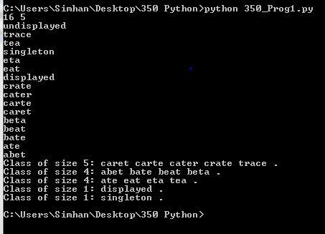

1) Duplicate Test:

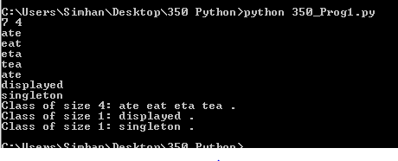

2) Number of Classes to print is greater than number of classes available to be printed:

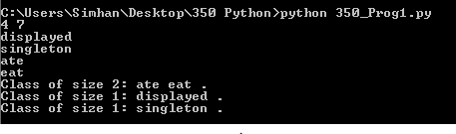

3) Sort Test (sort length, two classes of different lengths)

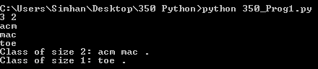

4) Sort Test (same length, two different classes, sort lexicographical)

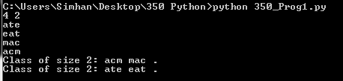

5) Prof. Elenbogen Test Cases:

